LeetCode Assignment
Question Name: Subtract the product and sum of digits
LeetCode question number: 1281
Platform: LeetCode
Problem link: https://leetcode.com/problems/subtract-the-product-and-sum-of-digits-of-an-integer/submissions/2193105029/
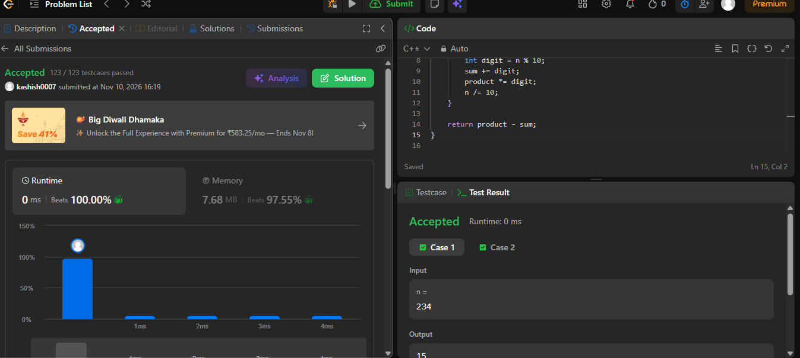

Name – Kashish Upadhyay
Roll no- 26csu254

